Academic Year: 2025-26 | Year: Second Year | Semester: II
PRN No.: 1012411011 | Name: Riddhee Kulkarni
Subject: Python Programming
Assignment No.: 14
Date: 02/02/2026

Lab Assignment: 14
Aim:
Write a program using function to check whether two numbers are equal or not.

Objective:
To understand the use of functions and conditional statements in Python.

Theory:
A function is a block of reusable code that performs a specific task.
In this program, a function compares two numbers using the equality operator (==).
If both numbers are equal, an appropriate message is displayed.

Algorithm:
- Start
- Define a function to compare two numbers
- Read two numbers from the user
- Compare the numbers using ==
- Display the result
- Stop

Pseudo Code:
FUNCTION check_equal(a, b)
IF a == b
PRINT "Numbers are equal"
ELSE
PRINT "Numbers are not equal"
END IF
END FUNCTION

Code:
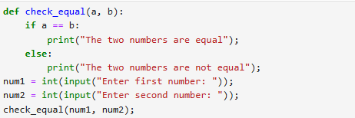

Output:
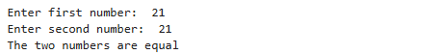
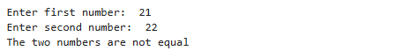

Conclusion:
The program successfully checks whether two numbers are equal using a function.

